Lab 10 manual: Index of refraction of water
Dr. D. Beznosko
6/9/2026
For PHYS 1112L only
(Lab outcomes: measuring angles and refraction index. Error propagation application to angles. Laser safety.)

Abstract
The Snell’s law is used to measure the refraction index of water. Laser safety is explained, and goniometer is introduced. The angle errors are propagated through all equations.

Introduction
The refraction n is the property of all materials, even non-transparent – in general, $n$ is complex, and the imaginary part is the absorption, so non-transparent media will have only the imaginary part. Can $n$ be less than 1 or negative? Can you find any more examples and practical uses?

Experimental Setup
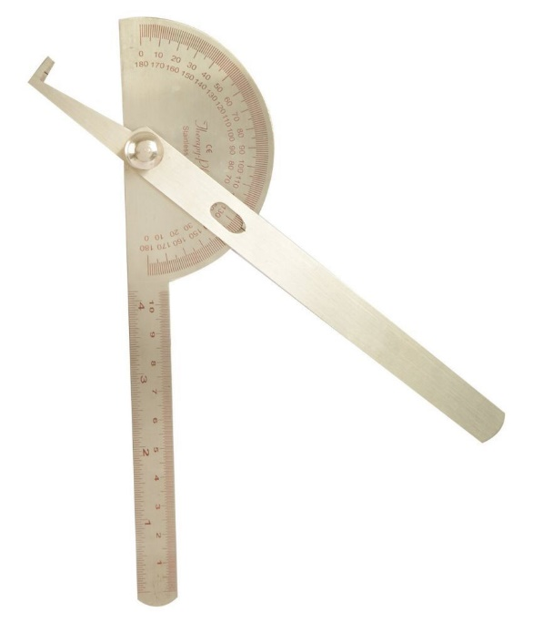
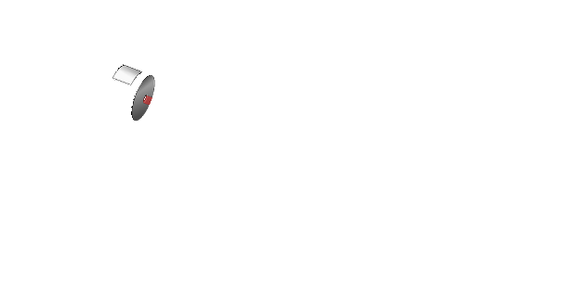
The experimental setup in Figure 1 shows the glass reservoir for water, the laser, and the goniometer. A piece of sticky tape is used for the screen.
Figure 1: The experimental setup schematic.
Screen
Goniometer
Laser
Water reservoir with glass walls
Light path without water
Light path with water
Distance between walls

Procedure
Listen to laser safety very carefully. Never look at the laser directly (the light emission point), never point it at any person or reflective surface!!
Fill the apparatus with water. Place the sticky tape on the reservoir wall. Do the measurements at $0^{o}−{60}^{o}$. Mark all laser beam positions on the tape. Make sure that you aim the laser correctly (instructor will demonstrate). What is the error on $θ_{air}$? Measure distances of all points on the take from the 0-angle point. What is the error on these measurements? Remove the water first, then use the caliper to measure the distance between the glass walls as indicated in Figure 1. Consider the error for this measurement as well.

Experimental Data
The results of the measurements should be organized as Table 1 or similar. Think about how to organize this table. The error can be listed in a different column or as value ± error unit. Don’t include all data values here, only relevant means, stdev etc. In most cases, all data points are not needed, especially for computer-based labs.
Table 1: Experimental data.
Quantity name | Measured value, units
Incident angle, in degrees or radians | Points distance from 0-angle position, m
$$θ$$

Provide description about each entry as needed, don’t just leave the table without text in this section. Organize well so that data takes up less space, but everything needed is included.

Theory
Consider equation 1 that described Snell’s law.

$$n_{1}sinθ_{1}=n_{2}sinθ_{2}\left(1\right)$$

with $n$ being the refractive indexes of media one and two, $θ$ – angles to the normal to the interface. Always use equation editor and number the equations so that they later can be referenced as eq. 1 or equation 1. You will need other equations and derivations in this section. For example, the equation for $sinθ_{2}$ and all error propagations!

Analysis
First, show that the glass walls don’t interfere with the measurement. Hint – write all interfaces as a single expression and see which n cancel!
Rewrite equation 1 so that when plotted, $n_{water}$ is the slope. Propagate all errors to find error bars. For the sine of the angle in water, there is no need to find the angle $θ_{2}$ itself – all we need is the $sinθ_{2}$ and you have the sides of the triangle! This is easier in terms of error propagation.
For the incident angle, there is no way to avoid the use of the derivative. Just recall that $\left(\frac{∂}{∂θ}sinθ\right)Δθ=cosθ∙Δθ$with the delta theta is radians! So, $Δθ_{1}=cosθ_{1}∙Δθ_{1}$.
Use https://sos.clayton.edu/physics/chi2/. Find the slope and compare it with the accepted value for water refraction index within errors. (Hint – remember all other things to find as with any plot!)

Conclusion
Comment on your result and the methods used to find it. What did you learn in performing this measurement? Where else can it be used? Can it be improved?

Here, another option is available. Remember from 1111L, there was a method $0.68∙\left(sin\left(θ+Δθ\right)−sin\left(θ−Δθ\right)\right)$. Here, all angles and errors can be in degrees.

